How to set-up your Protx integration with Actinic

This document provides details on how to integrate your Actinic cart with the Protx VSP System. Actinic is a 3rd party cart and any questions you have about the Actinic cart set up should be forward to Actinic directly.

- Setting up your cart

- Configuring your PSP

- FAQ’s & Error messages

- Payment Types ( PreAuth and Deferred)

- Going Live

How to set-up your Protx integration with Actinic

In order to use a third-party payment gateway, such as Protx, you need to ensure you have the correct version of Actinic, as only version 6 is set-up by default to work with the VSP Form integration type.

If you are using version 5.11 or above you will need to download our update patch from here:

http://www.protx.com/support/actinic.asp

If you are using V5.00 or below of Actinic you must upgrade to a later version before trying to integrate with Protx. Actinic will advise how to go about this – www.actinic.co.uk

Setting up your Actinic cart

Once you have logged in to your Actinic admin area you need to select the ‘Payment and Security’ tab within ‘Business Settings’.

Actinic ‘Business Settings’ section…

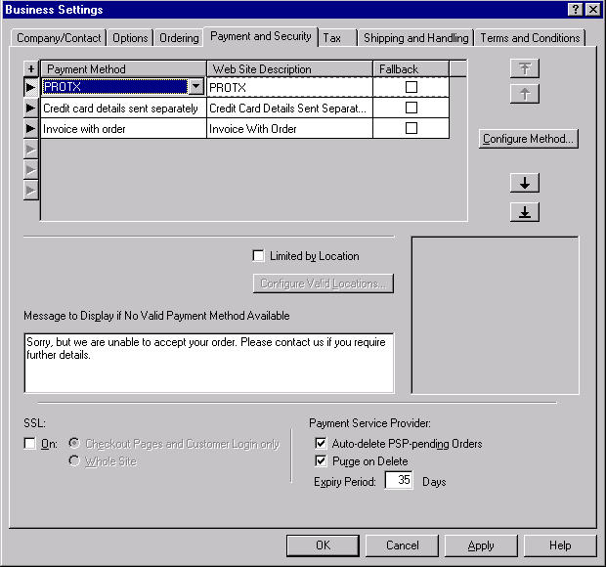

If you are using V6, or you have successfully installed the Protx upgrade patch, you will have the option of selecting ‘PROTX’ from the available payment methods.

Once you have selected ‘PROTX’, click ‘Configure Method’ to enter your vendor specific details (see next page).

Configuring your payment service provider (Protx)…

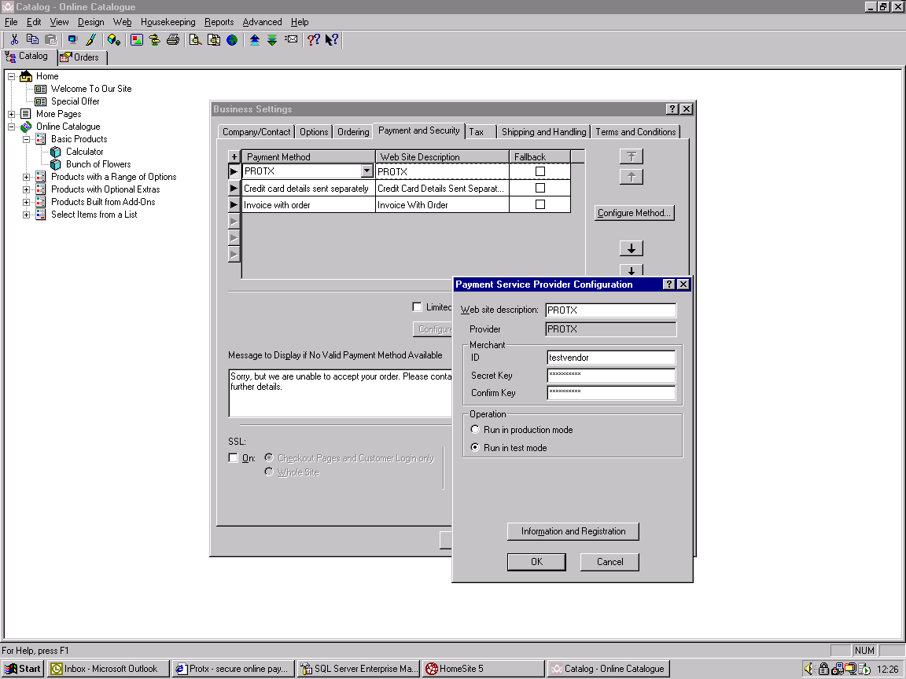

Enter your Protx issued vendor name in the ‘Merchant ID’ field and the Actinic secret key (also issued by Protx) in the ‘Secret Key’ and ‘Confirm Key’ fields. The secret key is case sensitive; therefore please take care when entering it.

You should leave the settings at ‘Run in Test Mode’ for the time being, as you will only have a test account at this time. Once you have requested and been provided with a live account, you simply have to change this to ‘Run in Production Mode’, as the passwords are the same.

Once you’ve saved these settings you will need to enter the encryption password.

Entering your encryption password

To enter your encryption password please go to the ‘OCCUpgrade’ directory. Within this directory you will find a folder called ‘CommonOCC’.

Find the file called ‘OCCProtxScriptTemplate.pl’ and open it with text editing software, such as ‘Notepad’.

Once you have opened this file, look for the following lines of code:

#####################################################################
# PROTX VPS Specific constants here
#####################################################################

my $sPassword = 'testvendor';
my $sConfirmationEMail = '';

#####################################################################

Enter your user specific 'encryption' password in the $sPassword field replacing testvendor.
If you wish to receive e-mails from Protx when a transaction is completed, cancelled, not authorised etc. then enter your e-mail address in the $sConfirmationEMail field. If you don't want them, leave it blank.

OCCProtxScriptTemplate.pl (viewed through UltraEdit)…

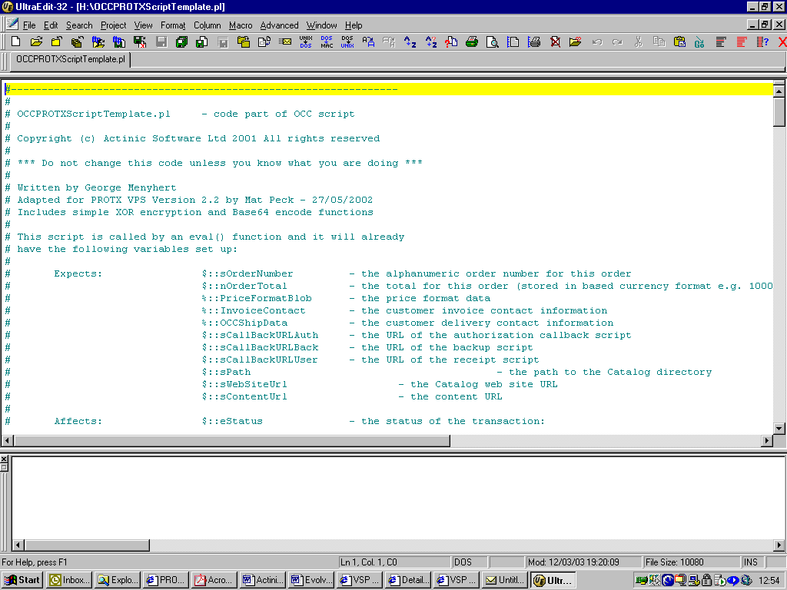

Updating OCC Upgrade file

The final step is to change the version number in the ‘OCCUpgrade.ini’ file, found in the ‘OCCUpgrade’ directory. In some versions of windows the file is only displayed as ‘OCCUpgrade’, but you can check by looking at the properties. Open it in a text editor as you did when updating the ‘OCCProtxScriptTemplate.pl’ file.

OCCUpgrade.ini (viewed through UltraEdit)…

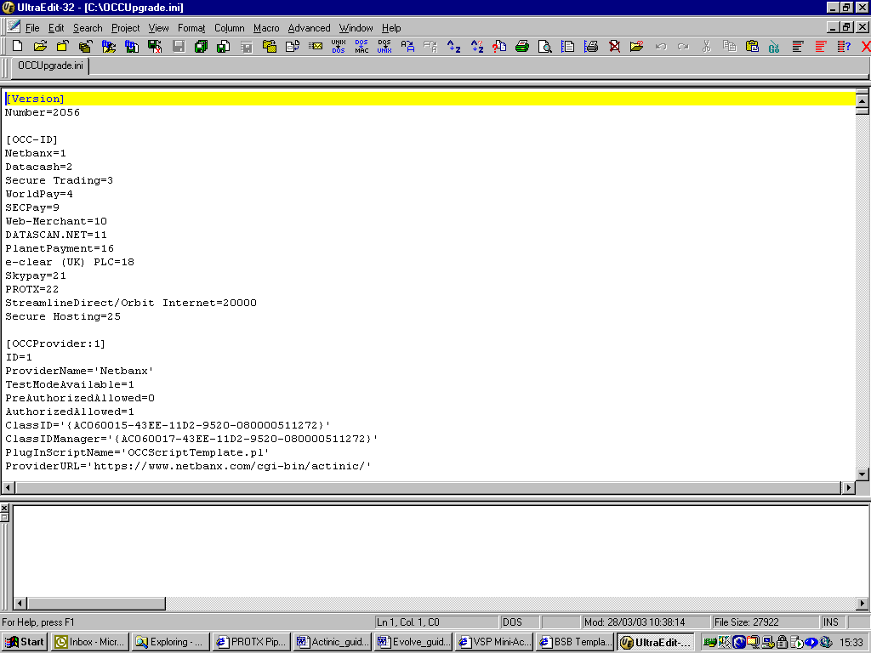

At the top of this file you will see the following text:

[Version]
Number=2056

Increment the number by one (in this example it would become ‘2057’) then save the file.

Close down Actinic

You should now close down Actinic and open it again. When you open Actinic again, you will see a message to say your payment service providers have been updated. You should accept this change and then continue.

Upload your web site

Once you have entered all the appropriate information you will need to re-upload your modified web site to your web server. This will then enable you to carry out test transactions against the Protx payment gateway.

Frequently Asked Questions

What if I don’t have my vendor name and secret key yet?

A unique Vendor name and password are provided when Protx create a test account for you. This data is emailed to the contacts registered on the account. Please email support@protx.com if you need reminding of your passwords.

You must ensure that you have registered for an account with Protx, otherwise you will not be able to go Live. You can register for an account using the following URL: https://www.protx.com/apply

I get an error message saying ‘The VendorTxCode field may be missing or you may have used an incorrect encryption password’.

This is normally caused by the encryption password being entered incorrectly in OCCProtxScriptTemplate.pl. The encryption password is the 16-character string that will look something like:

IopFg1GhwzQSFhIm

This should not be confused with the Actinic Secret Key or Admin password.
If you need reminding of your passwords please email support@protx.com

When I download my orders I get an ‘Invalid Signature’ status.

This is caused by the Actinic Secret Key being entered incorrectly. The Actinic Secret Key is the 12-character string that will look something like:

KotwWr56RtaW

This should not be confused with the Encryption Password, which is 16 characters in length. If you need reminding of your passwords please email support@protx.com

My Vendor name appears on the Payment pages where it says “To Pay For”. How can I change this?

Within Actinic, the default settings pick up the Actinic MerchantID, (which is your Protx Vendorname). To change the name that appears after the text "To Pay For" on the Protx payment pages you will need to change the following at your end:
1.) OCCProtxScriptTemplate.pl
You will need to amend the OCCProtxScriptTemplate.pl file located within your actinic directory. (OCCUpgrade/commonOCC/)
You will need to find the following bit of code:
$sCrypt .= "Description=Items from ". $sMerchantID . "&";
and change to:
$sCrypt .= "Description=Items from YOUR CHOICE OF WORDING&"; (make sure that the &"; remain)
2. Then save the file.
3. occupgrade.ini
Look for the following file within your Actinic directory (OCCupgrade /occupgrade.ini)
Open the file and increase the version number by 1 (so if 1045, change to 1046) Then save the file.
(This acknowledges the changes you made in 1.)
4. Open up your Actinic again and it should mention that a change has been made to your PSP.

Payment Types

Payment types are the type of transaction /method to which you send your transactions to the bank. The default setting within Actinic will be PAYMENT. This means the transaction will be passed to the bank for authorising and if successful, will be sent for settlement to the banks by Protx at 2am. (So funds will be transferred unless you decide to Void / cancel it).

There are two other transaction types that you can use. They are the PREAUTH or DEFERRED transactions types.

1. PREAUTH & Repeat

A transaction is made and the bank authorises it. It will then come back to the Protx System which will reverse / cancel it, so no money has actually changed hands. (Removing the shadow on the customer’s card). Your Protx VSP Admin Reports pages will show a PreAuth transaction has taken place and will give you the option to 'Repeat' the transaction, in the form of a Repeat button, when you want to ship the goods and receive funds. You must send a 'Repeat' request to obtain funds. (We recommend you ship the goods after the Repeat transaction has been processed successfully.) If there are no funds in the customers account when you 'Repeat' the transaction, you will know this straight away as the transaction will be declined by the bank. You obviously do not ship the goods if this is the case and call the user up to get another card number and either use your VSP Terminal in your Protx VSP Admin reports pages or get them to order via your website again.
The Repeat option allows you to part ship goods, by 'repeating' for the amount of the goods that you are able to ship. You can then repeat against their transaction for the other part of their order when it is available to ship.
You are able to repeat against these card details at any time, for any amount and as many times as you like. It will use the Pre Authorised details and send them back to the bank to be authorised again or declined if funds are not available etc. A PreAuth is never settled, only the subsequent Repeats. (The only way to have funds transferred it to repeat the transaction.)
If you decide, for whatever reason, not to continue with the PreAuth transaction, you simply leave the transaction alone. You do not need to do anything as No money has been taken.
NB: The Refund or Void options are only available on Repeat transactions, as a request for funds have been made.
NB2: The One issue with using the PreAuth transactions type is, if the banks ignore our online reversal / cancellation message for what ever reason, which they can do on occasion, the PreAuth transaction will stay in their active transaction list awaiting settlement. This means the banks will shadow the customer’s card for the amount of the PreAuth transaction not allowing the funds to be used for anything else. So if you try to Repeat the transaction to go and get your funds, while the card is shadowed, the users may not have any funds left and the transaction will fail. (I.e. if the user has £100 on their card and their order is for £70. The PreAuth will shadow the card for £70, leaving £30 on the card. If the banks ignore our cancellation message and you try to process the repeat for £70, the banks will only have 30 available and fail the transaction.
If this occurs you can contact your merchant services and request they remove the shadow as the transactions will never be settled. This can only be done by you, the merchant as the funds are being requested by you, or the customers, as it is their card. Protx cannot remove any shadows and cannot influence this in anyway.
If the customer has sufficient funds for PreAuth and the Repeat, the customer may think they have been charged twice, but they have not. The PreAuth will never be settled and the shadow will be removed. They will only be charged for the Repeat.
2. DEFERRED & Release:
A transaction is made and the bank authorises it. This transaction is held in the banks active transaction list and the customer’s card is shadowed for the transactions amount. The VSP Admin Reports will show a Deferred transaction has taken place and will give you the option to Release the payment when you wish to ship the goods. The transaction would have taken place and the customer’s card will have been shadowed, awaiting your 'release'. (No money would have changed hands unless you release the transaction.)
When you wish to ship the goods, you click the 'Release' button on the transaction page in your Protx VSP Admin reports pages and the bank will go and get the money from the users account and put it into your account.
NB: The shadow only lasts up to 7 days, depending on the card issuer, so if you ship your goods before the shadow expires, you will get your money. If you ship your goods after the shadow has expired, you will not know if you have been paid until you see you bank statement. The banks do not reply to the 'release' informing us if they still have the funds in their account.
You only have the option to 'Release' or 'Abort' the transaction. So the Deferred transaction type is not an option if you are wanting to part ship goods.
If you do not wish to ship and wish to abort the transaction, you can click 'Abort' button in your VSP Admin Reports pages.

I want to use PreAuth / Deferred
If you wish to use PreAuth or Deferred and are not sure if you are setup to do so, please email support@protx.com to request the desired transactions Type.
You will need to have this set up on your Protx account in order for you to use them.
Once allocated to your Protx account, you will need to amend your Actinic cart settings. Please follow What to do section. You will have to make the amendments at your end. This is not something that Protx can do for you.
What to do.
Actinic requires you to amend code in your shopping cart setup to use the PREAUTH or DEFERRED transaction types
Currently your TXType that you send to us will be 'PAYMENT'
If you wish to use 'PREAUTH' or 'DEFERRED' you will need to change the TXType in your OccProtxScripttemplate.pl file in your Actinic directory from:
'PAYMENT' to 'PREAUTH' or ‘DEFERRED’
1. Amend your OCCProtxScriptTemplate.pl file:
The OCCProtxScriptTemplate.pl file is located in the commonOCC folder in the OCCUpgrade folder within your Actinic directory. Open the file in an editor like notepad and search for 'TxType':
$sHiddenValues .= "<INPUT TYPE=HIDDEN NAME=\"TxType\" VALUE=\"PAYMENT\">\n";
You will need to change the TXType from PAYMENT to PREAUTH or DEFERRED.
$sHiddenValues .= "<INPUT TYPE=HIDDEN NAME=\"TxType\" VALUE=\"PREAUTH\">\n";
or
$sHiddenValues .= "<INPUT TYPE=HIDDEN NAME=\"TxType\" VALUE=\"DEFERRED\">\n";
Then save the file.
2. Amend the OCCUgrade.ini
The OCCUgrade.ini file located in the root of the OCCUpgrade folder in your Actinic directory. Open the file in an editor like notepad.
At the top of the file are the lines that look like this:
[Version]
Number=1045
Increment the Number (like the example above) by 1 and save the file.
(NB: this needs to be done every time you amend the OccProtxScriptTemplate.pl file)
3. Open up Actinic.
You should get a message informing you that a change has been made to your Payment Provider data and that it has been.
When you amend your Actinic code to use a certain transaction type, all your transactions will then be processed as that transaction type.

Protx VSP Admin Reports pages:

Your Protx VSP Admin reports pages will show the transactions as Payment, PreAuth or Deferred transactions.

If you wish to Repeat / Release a PreAuth / Deferred transaction, you go into your Protx Reports pages and locate the transaction in question by using the 'Transaction' Button. Go into the transaction details page, (by clicking on the VendorTxCode) and click the 'Repeat' or 'Release' button at the bottom of the page.

If you do not wish to continue with the transaction, simply ignore the PreAuth transaction (as PreAuths are never settled so no money has or will change hands), and ‘Abort’ the Deferred transaction by clicking the ‘Abort’ Button.

It is up to you to amend your cart settings and to make sure that your cart is using the transaction type you want it to use.

NB: When repeating a transaction, make sure that you are repeating a PreAuth transaction, not a Payment.

How do I go Live

Once you have successfully tested your web site with Protx, simply send your logo and go-live request to golive@protx.com
The Protx Live team will check that you have completed the live criteria and will create a Live account on the Protx Live Servers. You will then be able to run in ‘production mode’.

Your logo should be no larger than 200 pixels wide or 100 pixels high, and will be uploaded on to your live payment pages when your live account is created.

If you have a questions please email support@protx.com or contact Actinic directly.

When Live, my Site does not redirect to the Payment pages:

When changing from 'test' to 'production' mode within Actinic, the 'next' button, that transfers the users to the payment pages, is removed. Some Java script is supposed to handle this process, to auto redirect the user, but it may not be present in your Actinic templates.
If you are having issue directing the users to Protx, you can put the next button back.
1. act_occprotxtemplate.html
Look for the following file within your Actinic directory (OCCupgrade / CommonOcc/ act_occprotxtemplate.html)
Open this file, find and amend the following:
NETQUOTEDEL:TESTMODE
<INPUT TYPE=SUBMIT NAME="\&quot;SUBMIT\&quot;" VALUE="Next&gt;">
NETQUOTEDEL:TESTMODE
Change this to:
<INPUT TYPE=SUBMIT NAME="\&quot;SUBMIT\&quot;" VALUE="Next&gt;">
Basically removing the two references of NETQUOTEDEL:TESTMODE
Then Save the file
2. Locate the following file: occupgrade.ini
Look for the following file within your Actinic directory (OCCupgrade /occupgrade.ini)
Open the file and increase the version number by 1
(so if 1045, change to 1046)
Then save the file. (This acknowledges the changes you made in 1.)
3. Upload Your Site
Now that you have made changes to your setup you will need to re-upload your site
4. Test
When you have uploaded your site please test to make sure the redirect works, when you click the next button

